UNIT – 2
Machine Learning
Machine Learning is a branch of Artificial Intelligence that enables computer systems to learn patterns from data and improve their performance over time without being explicitly programmed for every task. Machine Learning is an AI approach that empowers computers to learn from data, identify patterns, and make decisions. It supports supervised, unsupervised, and reinforcement paradigms and often outpaces traditional programming in flexibility and capability. While it's advancing rapidly across many domains, it presents challenges in fairness, transparency, and data ethics.
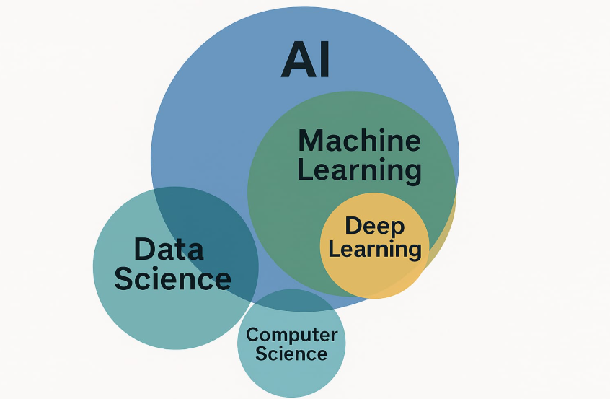
What is human learning?
Human learning is the process by which people acquire knowledge, skills, behaviors, and attitudes through experience, social interaction, and reflection. It’s a complex, lifelong activity involving mental, emotional, and environmental dimensions.
- Cognitive Perspective:
Human learning involves perception, memory, attention, reasoning, and decision making not just stimulus-response behavior .
- Observational (Social) Learning:
Learning by watching others and modeling their behavior. It relies on attention, retention, reproduction, and motivation
- Operant Conditioning:
Learning through consequences rewards increase behavior, punishment based on behavior.
This learning arises through various channels such as classical conditioning, operant conditioning, observational learning and cognitive or constructivist processes involving mental organization, reflection, and problem-solving. It’s an active and multifaceted process that unfolds over time, heavily influenced by motivation, social context, feedback, and prior knowledge.
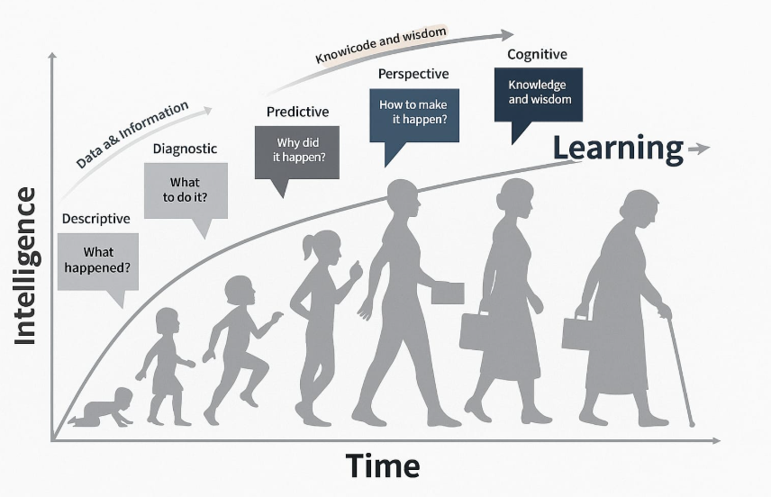
Human learning is essential for adapting to new situations, solving problems, and acquiring the skills necessary for personal and professional development. It enables individuals to make sense of their experiences, build upon prior knowledge, and apply learning to novel contexts. Moreover, learning is a lifelong process, continuing throughout an individual's life, and is influenced by a combination of internal factors (like motivation and cognitive abilities) and external factors (such as social interactions and cultural context).
Understanding the processes and theories of human learning can inform educational practices, enhance teaching strategies, and support the development of effective learning environments that cater to diverse learners.
Types of Human Learning
- Classical Conditioning:
Learning by associating two stimuli (e.g., a sound and an event).
- Operant Conditioning:
Learning through consequences like rewards or punishments.
- Observational Learning:
Learning by watching and imitating others.
Human learning happens in three ways
- Learning under expert guidance.
- Learning guided by knowledge gained from experts.
- Learning by itself.

- Learning under expert guidance: Learning under expert guidance refers to the process where a learner acquires knowledge, skills, or attitudes with the direct support, instruction, and feedback from a knowledgeable teacher, mentor, or expert.
- Learning guided by knowledge gained from experts: This type of learning occurs when individuals study and apply information, concepts, or skills that have been previously discovered, organized, and shared by experts—without direct interaction with the expert.
- Learning by itself: Learning by itself refers to the process where an individual acquires knowledge or skills independently, without direct instruction or reliance on expert-created materials. It often involves exploration, experimentation, and critical thinking.
What is Machine Learning?
Machine Learning (ML) is a rapidly evolving branch of artificial intelligence that enables computers to learn from data and improve their performance on specific tasks without being explicitly programmed. By analyzing this data, these systems develop models that can make predictions, classify information, or make decisions when exposed to new, unseen data. Machine learning can be broadly categorized into three types: supervised learning, where the algorithm learns from labeled data with known outcomes; unsupervised learning, which involves discovering hidden patterns or groupings in data without pre-existing labels; and reinforcement learning, where an agent learns to make sequences of decisions by receiving feedback in the form of rewards or penalties. Machine learning started as a concept in the 1950s, gradually developed through new algorithms and computing power, and today powers many intelligent systems we use daily. Machine Learning has a rich history that dates back to the mid-20th century. The foundation was laid in the 1940s and 1950s with early ideas about artificial intelligence and computing, including Alan Turing’s proposal of machines that could learn. In 1959, Arthur Samuel created one of the first machine learning programs.
Types of Machine learning
1. Supervised Learning:
The algorithm learns from labeled data, meaning each training example includes input data and the correct output. The goal is to learn a mapping from inputs to outputs to predict labels on new data. The primary objective is for the algorithm to learn a mapping function that can accurately predict the output for new, unseen inputs. During training, the model analyzes many examples where the correct answer is known, such as images labeled with the objects they contain or emails marked as spam or not spam.
2. Unsupervised Learning:
The algorithm works with unlabeled data and tries to find hidden patterns or structures, like grouping similar items together (clustering) or reducing data dimensions. the model tries to identify hidden patterns, structures, or relationships within the input data itself.
3. Semi-Supervised Learning:
Combines both labeled and unlabeled data to improve learning accuracy, especially when labeled data is limited or expensive to get. In this method, the model is trained on a small amount of labeled data along with a larger pool of unlabeled data.
4. Reinforcement Learning:
An agent learns by interacting with an environment, receiving rewards or penalties based on actions taken, aiming to maximize cumulative reward. Reinforcement learning is a type of machine learning where an agent learns to make decisions by interacting with an environment and receiving feedback in the form of rewards.

Problems not to be solved using machine learning
While machine learning is powerful, there are certain types of problems where it is not the best solution or may even fail entirely.
- Poor quality of data: Poor quality data is a significant challenge in machine learning (ML), affecting model performance, reliability, and trustworthiness. Data quality issues can arise from various sources and have profound implications across different stages of the ML lifecycle.
- Underfitting of training data: Underfitting in machine learning occurs when a model is too simplistic to capture the underlying patterns in the training data, resulting in poor performance on both the training and test datasets. This typically manifests as high bias and low variance, where the model makes strong assumptions about the data and fails to adapt to its complexities.
- Overfitting of training data: Overfitting occurs when a machine learning model learns not only the underlying patterns in the training data but also the noise and outliers, leading to a model that performs exceptionally well on the training set but poorly on unseen
- Machine learning is a complex process: Machine learning (ML) is indeed a complex process, involving multiple stages and considerations that require careful planning and execution.
- Lack of training data: Lack of sufficient training data is a significant challenge in machine learning (ML), especially for complex tasks or niche domains. Limited data can lead to overfitting, poor generalization, and unreliable model performance. However, several strategies can mitigate this issue:
- Slow implementation: Implementing machine learning (ML) solutions can be a slow and resource-intensive process. Several factors contribute to this delay, ranging from data preparation challenges to infrastructure limitations. Here's an overview of the key reasons behind slow ML implementation and strategies to mitigate these issues.
Application of Machine Learning
Machine learning has a wide range of applications across various industries, transforming how tasks are performed and decisions are made. By enabling computers to learn from data and improve over time without explicit programming, machine learning helps automate complex processes, uncover hidden patterns, and provide accurate predictions. The various application of machine learning are:
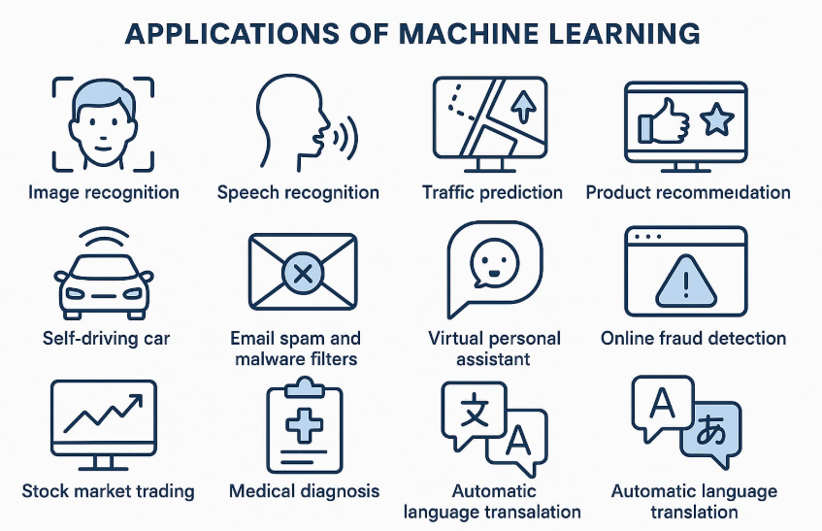
- Image Recognition: Image recognition is a key application of machine learning where systems are trained to identify and classify objects, people, places, or features in digital images.
- Speech Recognition: Speech recognition is a machine learning application that enables computers or devices to understand and convert spoken language into text. It allows humans to interact with machines using natural spoken language instead of typing, making technology more accessible and efficient.
- Traffic Prediction: Traffic prediction is a machine learning application used to forecast traffic conditions such as congestion levels, travel time, or route efficiency based on real-time and historical data. It helps improve transportation systems, reduce delays, and enhance road safety.
- Product Recommendation: Product recommendation is a popular application of machine learning used to suggest relevant products or services to users based on their preferences, behavior, or interests. It helps businesses personalize the customer experience and increase sales.
- Self-driving car: A self-driving car, also known as an autonomous vehicle, is a cutting-edge application of machine learning and artificial intelligence that enables a car to drive itself without human intervention
- Email spam and malware filters: are practical applications of machine learning that help protect users by automatically identifying and blocking unwanted, harmful, or malicious emails. TVirtual peronal assistant
- Online fraud detection: Online fraud detection is a critical application of machine learning used to identify and prevent fraudulent activities in real time, especially in financial transactions, e-commerce, and banking systems.
- Stock market trading: Stock market trading is a powerful application of machine learning, where algorithms are used to analyze financial data, predict stock prices, and make trading decisions with minimal human intervention.
- Medical diagnosis: Medical diagnosis is one of the most impactful applications of machine learning in healthcare. It involves using algorithms to analyze medical data and assist doctors in detecting, diagnosing, and predicting diseases more accurately and efficiently.
- Automatic language translation: Automatic language translation is a popular and powerful application of machine learning that enables the conversion of text or speech from one language to another. It helps break language barriers and makes global communication faster and easier.
Tools in Machine Learning
Machine learning relies on various tools libraries, frameworks, and platforms that make building, training, and deploying models easier and more efficient.
Python:
Python is a high-level, interpreted programming language known for its simplicity and readability. Developed by Guido van Rossum and first released in 1991, Python emphasizes code clarity and developer productivity, making it an excellent choice for both beginners and experienced programmers. Python is a high-level, interpreted programming language known for its simplicity and readability. Developed by Guido van Rossum and first released in 1991, Python emphasizes code clarity and developer productivity, making it an excellent choice for both beginners and experienced programmers.
Mtlab:
MATLAB ( MATrix LABoratory) is a high-level programming language and interactive environment developed by MathWorks. It's widely used by engineers, scientists, and researchers for numerical computing, data analysis, algorithm development, and system modeling. MATLAB is a programming and numeric computing platform designed for engineering and scientific applications. It includes a programming language, interactive apps, specialized libraries, and tools for automatically generating embedded code. MATLAB is also the foundation for graphical environment for modeling and simulating multidomain systems.
Saas:
Software as a Service (SaaS) is a cloud-based software delivery model where applications are hosted by a service provider and accessed by users over the internet. This model eliminates the need for local installation and maintenance, offering scalable, subscription-based access to software solutions. SaaS applications are typically built on a multi-tenant architecture, where a single instance of the software serves multiple customers.
Issues in Machine Learning
- There's a significant shortage of professionals with expertise in ML, data science, and AI, leading to increased competition for talent and potentially delaying project timelines.
- Training models on synthetic data can lead to rapid degradation of model performance, known as model collapse.
- Training large-scale ML models requires significant computational resources, which can be costly and environmentally taxing.
- Models can perpetuate biases present in the training data, leading to unfair or discriminatory outcomes.
Breach of privacy and sharing information publicly
- ML models might generate outputs that include confidential information, especially if trained on datasets containing such data.
- Failure to properly anonymize datasets can result in the re-identification of individuals, breaching privacy.
Preparing to model
- Preparing to model refers to the comprehensive process of transforming raw data into a structured and clean format suitable for training machine learning (ML) algorithms.
- Preparing to model refers to the comprehensive process of transforming raw data into a structured and clean format suitable for training machine learning algorithms. This phase, often termed Data Preparation or Data Preprocessing, is crucial for ensuring that the data is accurate, consistent, and aligned with the requirements of the chosen ML models.
- This phase, often termed Data Preparation or Data Preprocessing, is crucial for ensuring that the data is accurate, consistent, and aligned with the requirements of the chosen ML models.
Steps to prepare data for machine learning
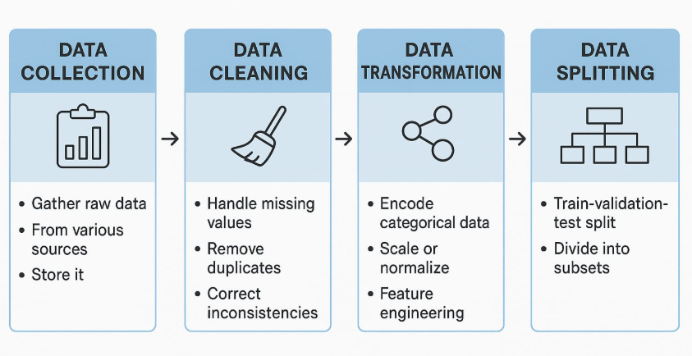
- Data Collection: Data collection is the foundational step in machine learning (ML), involving the systematic gathering of raw data from various sources to train models. The quality, diversity, and volume of the collected data directly influence the performance and reliability of ML models.
- Data cleaning: Data cleaning (also known as data cleansing or scrubbing) is the process of identifying and rectifying errors, inconsistencies, inaccuracies, or missing values in a dataset. This step is crucial for ensuring that machine learning models receive high-quality input, leading to more accurate and reliable predictions. Eliminate duplicate records to prevent redundancy and ensure the dataset's integrity. After cleaning, validate the dataset to ensure that the corrections have been applied correctly and that the data is ready for analysis.
- Data Transformation: Data transformation is the process of converting raw or disjointed data into a standardized and usable format. It optimizes data structure, format, and values so machine learning models can learn effectively and produce accurate
- Data Splitting: In machine learning, data splitting involves dividing your dataset into training, validation (or dev), and test sets to build robust models that generalize well. The training set is used to learn model parameters (e.g., neural network weights) and typically comprises around 60–80% of the data.
Machine Learning Activities
- Understand the type of data in the given input data set.
- Explore the data to understand the nature and quality.
- Explore the relationships amongst the data elements.
- Find potential issues in data.
- Do the necessary remediation.
- Apply preprocessing steps,as neccesary.
- Once the data is prepared for modeling, then the learning tasks start off. As a part of it, do the following activites.

- The input data s first divided in 4 parts. This step is applicable for supervised learning only.
- Consider the models or learning algorithms for selection.
- Train the model based on the training data for supervised learning problem and apply to unknown data.
- Directly apply the chosen unsupervised model on the input data for unsupervised learning problem.

- After the model is selected, trained, applied on input data, the performance of the model is evaluated.
- Based on option available, specific action can be takento improve the performance of the model.

Steps | Step Name | Activites involved
Step-1 | Preparing to Model | 1. Understand the type of data in the given input data set  2. Explore the data to understand data quality  3. Explore the relationship amongst data elements, inter-feature relationship  4. Find potential issues in data  5. Remediate data, if needed  6. Apply following pre-processing steps, as necessary:  a. Dimensionality reduction  b. Feature subset selection
Step-2 | Learning | 1. Data partitioning/holdout  2. Model selection  3. Cross-validatio
Step-3 | Performance evaluation | 1. Examine the model performance, e.g. confusion matrix in case of classification  2. Visualize performance trade-offs using ROC curves
Step-4 | Performance Improvement | 1. Tuning the model  2. Ensembling  3. Bagging  4. Boosting

